

Faculty of Engineering (Diploma)
Semester –5TH CE

Subject Name- COMPUTER ORGANIZATION AND ARCHITECTURE
Subject Code:- DE103504
Faculty Name –Khushbu Goswami

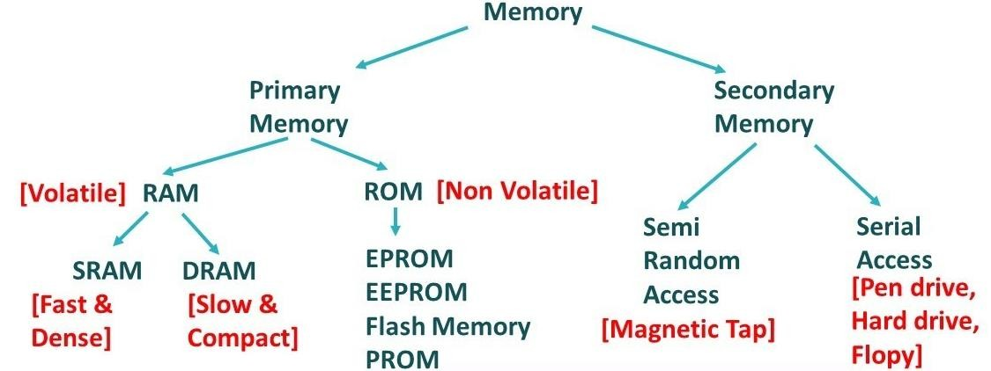
Unit :IV

Memory Organization

Memory classifications

Memory Hierarchy
      - GOAL : To obtain the highest possible access speed while minimizing the total cost of the memory system.
      - The memory unit that communicate directly with CPU is called Main Memory.
      - Devices that provides backup storage are called Auxiliary Memory.
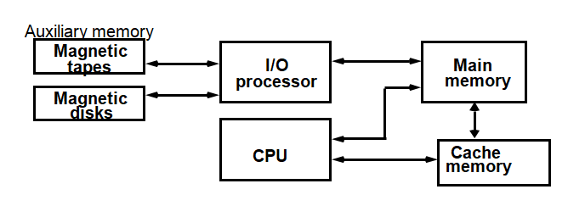

      - Only program and data currently needed by the processor reside in main memory.
      - The Main Memory communicate directly with CPU and with Auxiliary Memory Devices through an I/O Processor.
      - Cache is used to increase the speed of processing by making current programs and data available to CPU.
      - Auxiliary Memory has Large storage capacity, Relatively Inexpensive, Low access speed compared to main memory.
      - Cache Memory has Very small, Relatively expensive, very high access speed.

      - Advantage of Memory Hierarchy:
        - Increase capacity
        - Improve average access time
        - Decrease cost/bit
        - Decrease frequency of accesses to slow memory

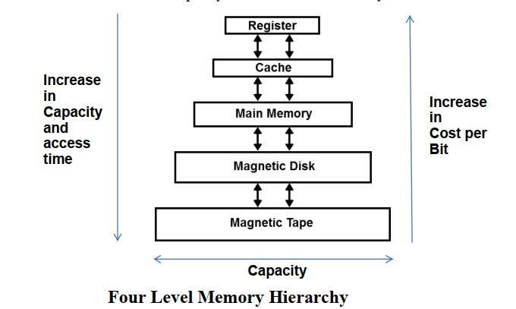

Various types of Main memories
- RAM
  - Random Access Memory
  - RAM losses its contents when the power is turned OFF. So, RAM is called volatile memory.
  - User save data in memory but they may not be store permanently.
  - It is called due to Random selection of Memory Location.
  - The microprocessor can write into or read from this memory.
  - Types of RAM are:
    - Static RAM (SRAM)
    - Dynamic RAM(DRAM)
  - Static RAM
    - It consists of flip flops that stores the binary information.
    - It is used in implementing the cache.
    - It is expensive, fast, low density, high power in operation.
    - Easy to use and shorter Read and Write cycles.
  - Dynamic RAM
    - It is used in implementing the main memory.
    - It stores the binary information in the form of electric charges.
    - It offers reduced power consumption and large storage capacity.

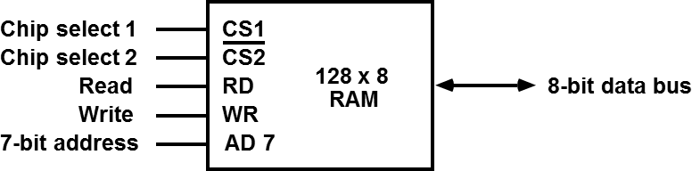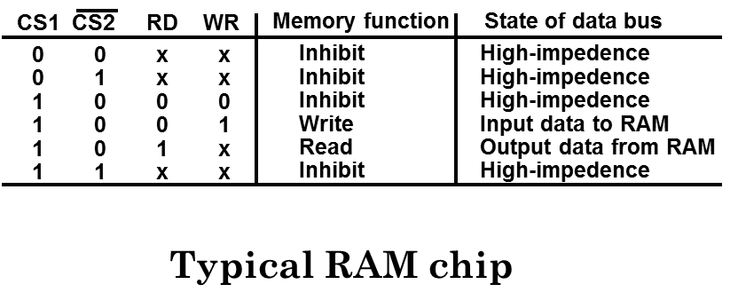
  - It has bidirectional data bus that allow transfer of data from Memory to CPU during Read or From CPU
to Memory during write operation.
  - High Impedance state behaves like an open circuit.
  - Each word is of eight bit.
  - It requires 7-bit address.
  - When the chip is selected, the two binary states in R/W specify the two operations of Read or Write.
  - CS2 bar indicates this input is enabled when it is equal to 0.

- ROM

  - ROM does not loss its contents when the power is turned OFF. So, ROM is called Non volatile memory.
  - The microprocessor can only read from this memory.
  - It is programmable once.
  - Types of ROM are:
    - PROM
    - EPROM
    - EEPROM
    - Masked ROM
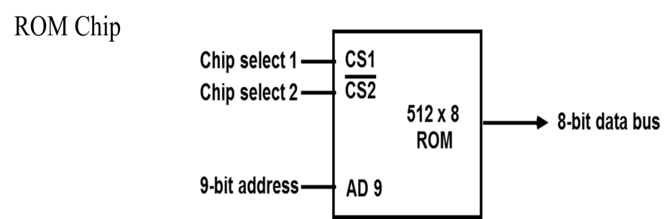

  - The two chip select inputs must be CS1=1 and CS2=0 for the unit to operate.
  - Otherwise the data bus is in High Impedance State.
  - When the chip is enabled by the two select inputs, the byte selected by the address lines appears on the data bus.

- PROM : Programmable Read only memory
  - PROM Programmer program in a blank chip.
  - Once you program it, You can never change.

  - It maintains large storage media but can not offer the erase feature.
  - Write Data once and Read many times.
  - It has poly silicon wires arranged in a matrix.
  - These wires can be functionally viewed as diodes or fuses.

- EPROM : Erasable Programmable Read only memory
  - This memory stores a bit by charging the gate of field effect transistor.
  - Information is stored by EPROM Programmer, which apply high voltage to charge the gate.
  - User can delete the data of EPROM through pass on Ultraviolet Light and the chip can be reprogrammed.
  - Chip can be used many times.
  - Erasing Process takes 15 to 20 minutes.

- EEPROM : Electrically Erasable Programmable Read only memory
  - Functionally similar to EPROM.
  - Information can be changed by using electrical signals at the register level instead of all the information.
  - Entire chip can be erased in 10ms.
  - This memory is expensive compared to EPROM.

- Associative Memory
  - Search Process:
    - Choose a sequence of addresses
    - Read the content of memory at each address
    - Compare the information with searched items.
  - A memory unit accessed by content is called an Associative Memory or CAM(Content Addressable Memory)
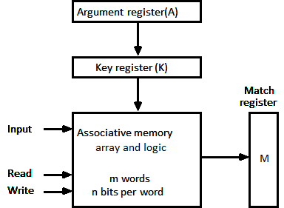

  - When a word is written in an associative memory, no address is given.
  - The memory is capable of finding an empty unused location to store the word.
  - When the word is to be read from memory, the content of the word is specified.
  - Associative memory is more Expensive than a RAM.
  - The argument register A and key register have n bits.
  - Match register M has m bits. Example: A 101 111100
K 111 000000
Word1 100 111100 No match
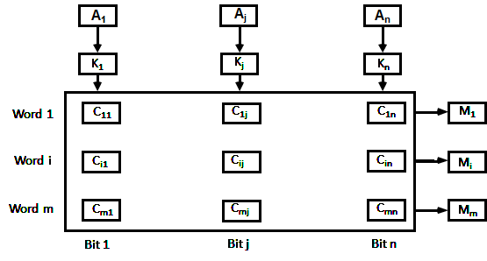
Word2 101 000011 Match Occur

Various types of Auxiliary memories
- Magnetic tape

  - It consists of magnetic, coating on a thin plastic strip.
  - Example: Recording Tap(used for audio, video, general purpose digital data storage using a computer)
  - Secondary Storage Device
  - Variety of Length( 600 to 3000 ft)
  - It is packaged in one of three ways:
    - Open Reel
    - Cartridge
    - Cassette
  - RW/WR heads are mounted on each track so that data can be recorded and read as a sequence of characters.

Information is stored in blocks referred to as records.
  - Each record on tape has an identification bit pattern at the beginning and end.
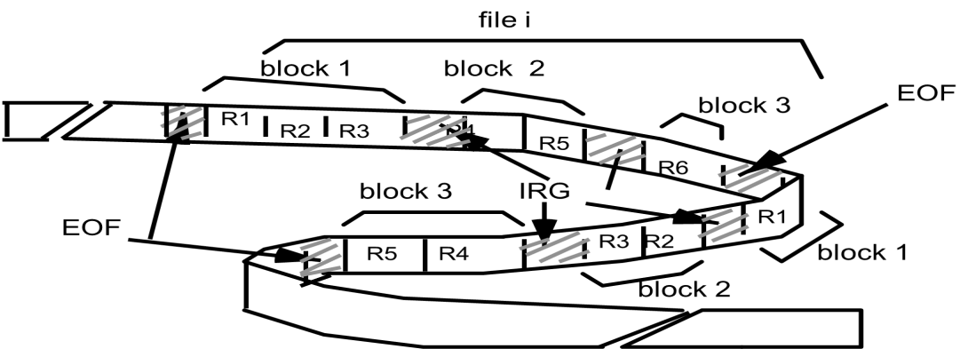

- Floppy disk
  - A disk drive with removable disk is called a Floppy Disk.
  - It is made of plastic coated magnetic material.
  - Type of Floppy:
    - 5 ¼ Inch: Capable of storing between between 100k and 1.2 MB of Data.
    - 3 ½ Inch: Small size, Larger storage capacity, Common size is 1.44 MB
  - It has Slower access than Hard Disk
- It has Less storage capacity, Less Expensive and Portable .

- Hard Disks
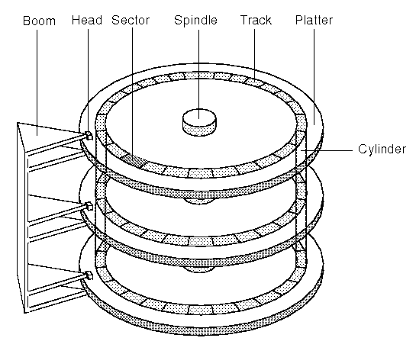
  - Bits are stored in magnetized surface along concentric circles are called Tracks.
  - Tracks are divided into sections called Sectors.
  - Some unit use a single Read/Write head for each disk Surface.
  - Some unit use a separate Read/Write heads for each track in each surface.
  - A disk system is addressed by address bits that specify the Disk number,Disk surface,Sector number and the Track within the sector.
  - How To Read/Write?
  - First Read/Write heads are positioned in the specified Track.
  - The system has to wait until the disk reaches the specified sector under Read/Write head.
  - Information transfer is very fast once sector has been reached.
  - Storage capacity of disk depends on bits per inch of track and Track per inch of surface.

- Flash Memory

  - It is Variation of EEPROM.
  - Flash memory is a non-volatile memory chip used for storage and for transferring data between a personal computer (PC) and digital devices.
  - It has the ability to be electronically reprogrammed and erased.
  - Flash memory is often used in systems that frequently rewrite data, such as USB flash devices or SD cards.
  - It is often found in USB flash drives, MP3 players, digital cameras and solid-state drives.
  - A flash memory chip is composed of NOR or NAND gates.
  - EEPROM and Flash memory have many differences, with one being their reading, writing, and erasure procedures of stored data.
  - EEPROM can read, write, and erase data at the byte level while Flash memory can also read and write at the byte level, but can only erase data at the block level.

Performance parameter of Auxiliary Memory

- Access Time: Time Required to reach a storage location in memory and obtain its content.
- Transfer Time: Time required to transfer data to or from the device.
- Transfer Rate: No of words/characters that device can transfer per second.

Cache Memory

      - Cache memory is a small, temporary fast memory.
      - It is placed between CPU and Memory.
      - It runs at speeds similar to CPU Registers.
      - Access Time is less than the access time of main memory.

Operation of Cache Memory:
      - When the CPU needs to access memory, the cache is examined.
      - If the word is found in the cache, It is read from that.
      - If the word is not found, the main memory is accessed to read the word and block of words are transferred from main memory to cache memory for future references.

Performance Parameter of Cache Memory
      - Hit: When the CPU refers to memory and find the word in cache , it is said to produce a HIT.
      - Miss: The requested data is not found in the cache memory, then it counts as a MISS.
      - Hit Rate: Performance of cache memory is measured in terms of quality, is called Hit Rate(Hit Ratio)

Hit Rate = No. of Hits / Total CPU references to Cache memory Hit Rate= No. of Hits / (Hits + Misses)
      - Miss Rate: The percentage of memory accesses not found in a given level of memory. Miss Rate=1- Hit Rate
      - Hit Time: The time required to access the requested information in a given level of memory.
      - Miss Penalty: The time required to process a miss, which include replacing a block in memory plus the time required to deliver requested data to the processor.

Writing into Cache
      - Read Operation: When CPU finds a word in a Cache Memory, Main Memory is not involved.
      - Write Operation: When CPU finds a word in a Cache Memory, Main Memory is involved.

Write Through Method:
        - When Cache memory is update, the main memory is also updated in Parallel.
        - Main Memory always content same data as cache.
Write Back Method:
        - Only the cache location is updated during a write.
        - The location is then marked by flag.
        - So, when the word is removed from cache, it is copied into memory.
        - When the word is resides in the cache, it may be updated several times.

      - The transformation of data from main memory to cache memory is referred to as a mapping process.
      - Types of Mapping:

Associative Mapping
- Direct Mapping

Set-associative Mapping
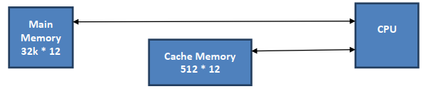
      - CPU First sends 15 bit address to cache.(32 * 1024=215 )
      - If There is a hit, CPU accepts 12 bit data from cache.

      - If there is miss, the CPU reads the word from main memory and the word is transferred to cache.

Associative Mapping
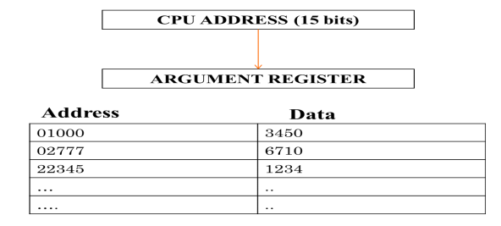
  - The associative mapping stores both the address and data of the memory word.
  - This permits any location in cache to store any word from main memory.

15 bits address is shown as a five digit octal number.
  - CPU Address of 15 bits is placed in Argument Register.
  - Then associative memory is searched for a matching address.
  - If the address is found, the 12 bit data is read and sent to CPU.
  - If no match occur, The main memory is accessed for the word.

Direct Mapping

  - The CPU address of 15 bits is divided into two fields.
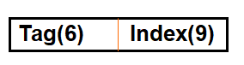
  - Main memory needs an address that includes both TAG and INDEX bits.
  - Cache Memory needs an address of index bits.
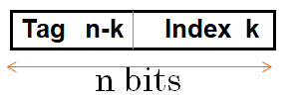
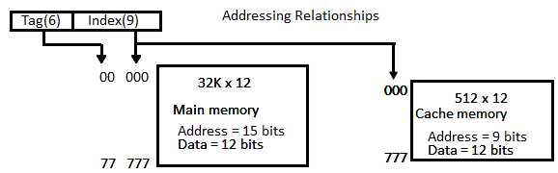

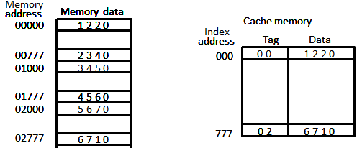
  - Each word in cache consists of the data word and its associated tag.
  - When the CPU generates a memory request, the index field is used as a address to access the cache.
  - The tag field of the CPU address is compared with the tag in the word read from the cache.
  - If the two tags match, there is a HIT and the desired data is in cache.
  - If the two tags do not match, there is a MISS and desired word is read from main memory and then stored in the cache with new tag.

Disadvantage:
  - Two or more words with same index but different tags are accessed repeatedly.

Set Associative Mapping
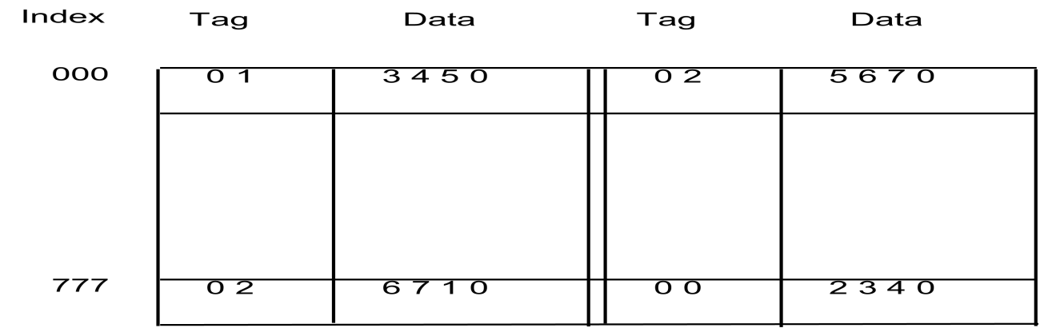

- Each word of cache can store two or more words of memory under the same index.
- Each data word is stored together with its tag.
- Each index refers to two data words and their Associated tags.
- Each tag require six bits and each data word has 12 bits.
- So, the word length is 2*(6+12)=36 bits.
- The size of the cache memory is 512*36.
- The word at addresses 01000 and 02000 of Main Memory are stored in cache memory at index address 000.
- Similarly, the words at addresses 02777 and 00777 are stored in cache at address 777.
- When the CPU generates a memory request, the index value of the address is used to access the cache.
- The tag field of the CPU address is then compared with both tags in the cache.
- When a miss occurs and cache is full then, it is necessary to replace one of the tag data items with a new value.

Virtual Memory
      - It is a concept used in a large computer system.
      - Give the programmer the illusion that the system has a very large memory, even though the computer actually has a relatively small main memory.

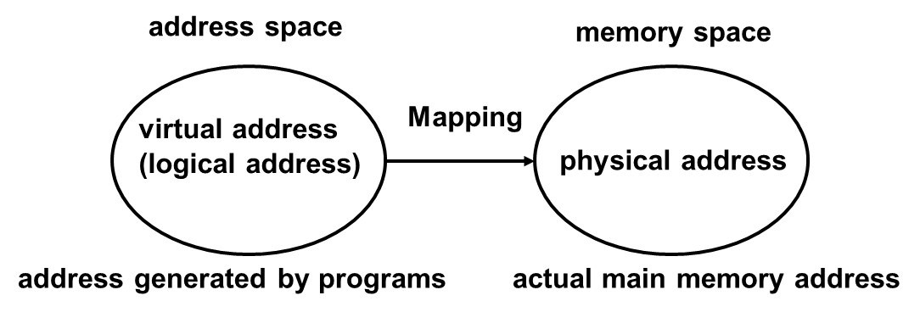
      - Virtual Address: An address used by a programmer.
      - Address Space: Set of Virtual Address.
      - Physical Address: An address in Main Memory.
      - Memory Space: Set of Physical Address.
      - Example:
- Main Memory: 32K→32 * 1024=2⁵*2¹⁰ = 2¹⁵ bits

Physical Address = 15 bits
- Auxiliary Memory: 1024 K→1024 *1024=2²⁰ bits

Virtual Address= 20 bits
- In a multiprogramming Computer System, programs and data are transferred to and from Main Memory and Auxiliary Memory.
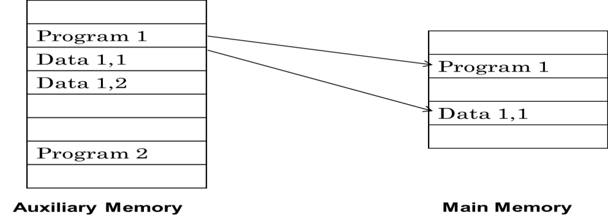

      - Address field of instruction code is 20 bits and physical memory is 15 bits. So, a table is needed to map a virtual address of 20 bits to a physical address of 15 bits.
